Group 2

Nicolas Hopkinson, Nefi Ferrari

WDD331R Section A4

Brother Rice

May 13, 2023

Zen Garden Project Week 1

**Theme**

For our Zen Garden project, we settled on the theme of Guatemala. We chose this because Néfi served his mission there, and Nicolas’ father served there. We are planning on using a mostly green and beige palate with red accents. We discussed incorporating a step pyramid into the background slightly muted behind the content. We both want to incorporate animation into our site, however, we are still working on where will be best. One current thought is to have the content slide out to build a pyramid but as has been stated, it is still in the process. We are both looking forward to this project and learning as we build.

**Colors**

The Celadon will be used for background. Desert Sand for Header and Footer. Dark Spring Green for the info Cards. Rufous for accents.

**Fonts**

We will be using Google Fonts for our font sources. For Headings we will be using Anton, a strong slab sans serif font that catches attention. For the body copy, we will use Abel, a simple sans serif with a more modern feel.

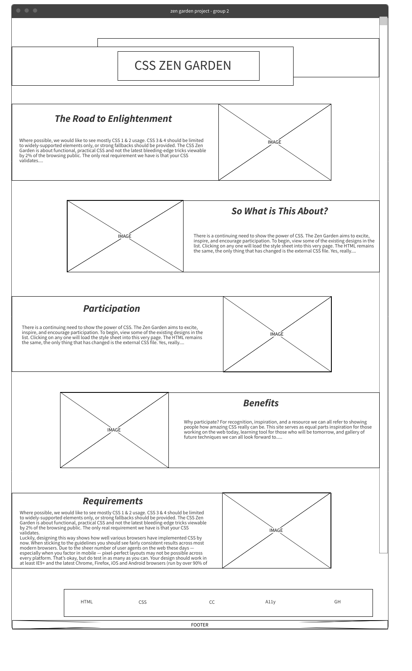**Wireframes  
  
- Normal screens**

* 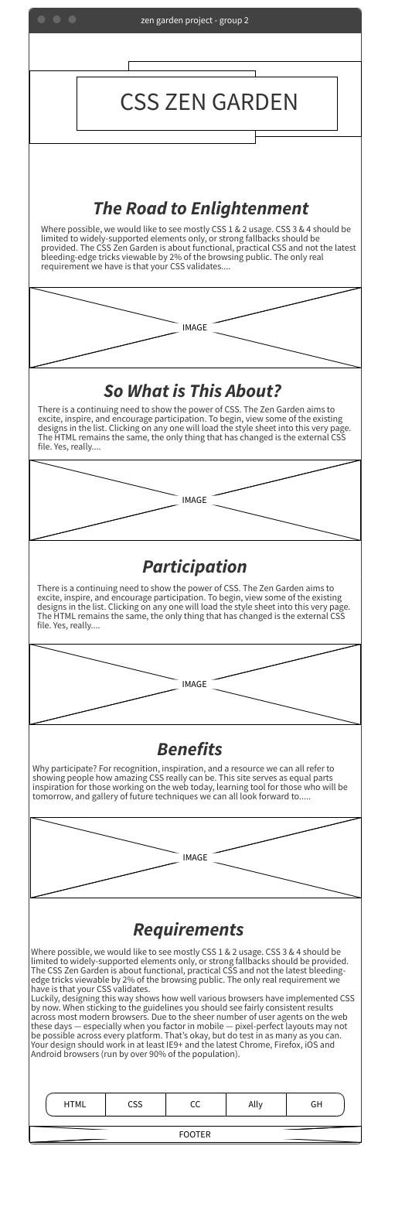Small screens